**Web VAPT**

**A Seminar Report**

**by**

**Khushboo Danidhariya**

**(PRN:**********)**

**MSc. Information Technology**

**Semester-II**

**under the guidance of**

**Mrs. Lavanya Sharma**



**Department of Computer Applications,**

**Faculty of Science,**

**The Maharaja Sayajirao University of Baroda,**

**Vadodara, Gujarat - 390002**

**Abstract**

Vulnerability assessment is the process of scanning software, such as operating systems and application software, and IT systems, such as computers and networks, to find known and unknown vulnerabilities.

Up to 80% of websites have security holes that might allow important company information, including credit card numbers and customer lists, to be stolen.

Web-based applications, such as shopping carts, forms, login pages, dynamic content, etc., are the focus of hackers’ attention. Backend corporate databases are easily accessed by unsecured web apps, which are accessible round the clock from any location in the globe.

So as a part of learning, I have taken one demo website which is already vulnerable to test and stated my findings based on the high severity in order to understand the vulnerabilities. Apart from that I have taken another live website to test on the basis of real-world scenario and find out the vulnerabilities with the concern of how actually you can perform a VAPT on a live website if we encounter it.

**CERTIFICATE**

This is to certify that the work contained in this seminar report entitled “**Web App VAPT**” submitted by **Khushboo Danidhariya** (PRN No:8023038162) to the Department of Computer Applications, Faculty of Science, The Maharaja Sayajirao University of Baroda towards the partial requirement of **Master of Science** in **Information Technology** has been carried out by her under my supervision and that it has not been submitted elsewhere for the award of any degree.

|  |  |
| --- | --- |
| Prof. Lavanya Sharma    Guide  Department of Computer Applications,  Faculty of Science,  The Maharaja Sayajirao University of Baroda | Head (Officiating)  Department of Computer Applications,  Faculty of Science,  The Maharaja Sayajirao University of Baroda |

**Acknowledgment**

I am greatly indebted to my guide Prof. Lavanya Sharma for her invaluable guidance during the course of the seminar. He always gave useful suggestions and also helped me when the work was not moving ahead at times.

Khushboo Danidhariya

MSC(IT)

**Table of Contents**



1. Introduction ……………………………………………………………………………………………………06
2. Overview…………………………………………………………………………………………………………08
3. Scope………………………………………………………………………………………………………………09
4. Web VAPT Methodology………………………………………………………………………………….10
5. Standards of Owasp Top 10 & own manual Methods…………………………………………11
6. Severity Description……………………………………………………………………………………….12
7. Scope Of Work & VAPT Findings………………………………………………………………………13
8. Vulnerability Table…………………………………………………………………………………………14
9. Enumeration Of Website…………………………………………………………………………………14
10. Technical narration of website vulnerability……………………………………………………38
11. Conclusion………………………………………………………………………………………………………55
12. References………………………………………………………………………………………………………56

**Introduction**

**Vulnerability Assessment:** This is the initial phase where security professionals use automated or manual methods to scan and analyze systems for known vulnerabilities. These vulnerabilities can include software bugs, misconfigurations, and other weaknesses that could be exploited by attackers. Vulnerability assessment helps organizations identify potential security risks and prioritize them based on severity.

**Penetration Testing:** Also known as ethical hacking, penetration testing involves simulating cyberattacks on a system or network to discover vulnerabilities that might not be detected through automated scans. Penetration testers, often referred to as “white-hat” hackers, attempt to exploit vulnerabilities in a controlled and ethical manner to demonstrate their potential impact. This testing helps organizations understand the real-world risks and how to mitigate them.

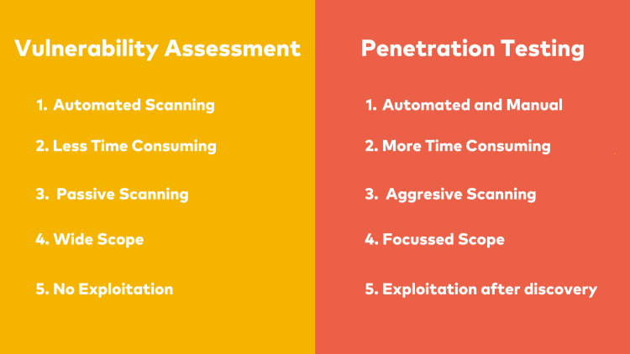

TYPES OF VAPT

**1. White Box Testing:**

  - In White Box Testing, also known as Clear Box Testing or Transparent Testing, the tester has full knowledge of the internal workings of the system or application being tested.

- White Box Testing allows for a comprehensive examination of the application's security posture, enabling testers to identify vulnerabilities at the code level.

**2. Black Box Testing:**

  - Testers approach the application from an external perspective, simulating how an attacker would interact with the system without any insider information.

    - Black Box Testing focuses on identifying vulnerabilities through real-world attack scenarios, such as SQL injection, cross-site scripting (XSS), and other common exploits.

**3. Grey Box Testing:**

- Grey Box Testing combines elements of both White Box and Black Box Testing approaches.

* Testers have limited knowledge of the internal workings of the system, such as high-level architecture and access permissions, but not full access to source code or detailed design documents.

**DOMIANS OF VAPT**

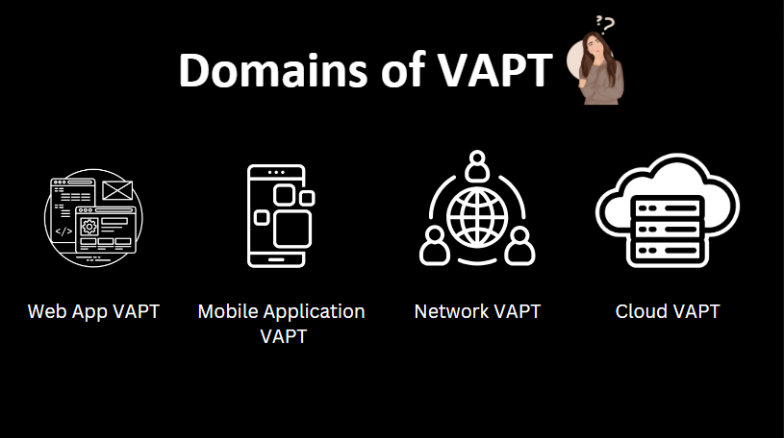

**Overview**



This report documents the findings for the Web Application Security Assessment of ABCD

Private Limited. The purpose of the engagement was to utilize exploitation techniques in

order to identify and validate potential vulnerabilities on the website.

**Scope**



* **Data collection**

Various methods including Google search are used to get target system data. One can also

use web page source code analysis technique to get more info about the system, software

and plug-in versions. There are many free tools and services available in the market which

can give you information like database or table names, DB versions, software versions,

hardware used, and various third-party plugins used in the target system.

* **Vulnerability Assessment**

Based on the data collected in first step one can find the security weakness in the target

system. This helps penetration testers to launch attacks using identified entry points in the

system.

* **Vulnerability Exploitation**

This step requires special skills and techniques to launch attack on target system.

Experienced penetration testers can use their skills to launch attack on the system.

* **Result analysis and report preparation**

After completion of penetration tests detailed reports are prepared for taking corrective

actions. All identified vulnerabilities and recommended corrective methods are listed in

these reports.

In this Penetration Testing, the testers will be trying to perform the above-mentioned tests

by Black Box & White Box testing. Black Box testing is when the testers are completely

unaware of the infrastructure, design and implementation of the product being tested.

White Box testing is when the testers are completely aware of the infrastructure, design and

implementation of the product being tested. The testers will be testing on the product in

certain scenarios provided by ABCD Private Limited and their results would depend on what

type of testing they can do and how vulnerable the web application is.

**Web VAPT Methodology**



VAPT is an important task to be carried out by security analyst. This is because of the rise in hacking attempts irrespective of the industry type. Attacks can happen from externally with no or little knowledge of the web.

1. Reconnaissance
2. Scanning
3. Exploitation
4. Reporting

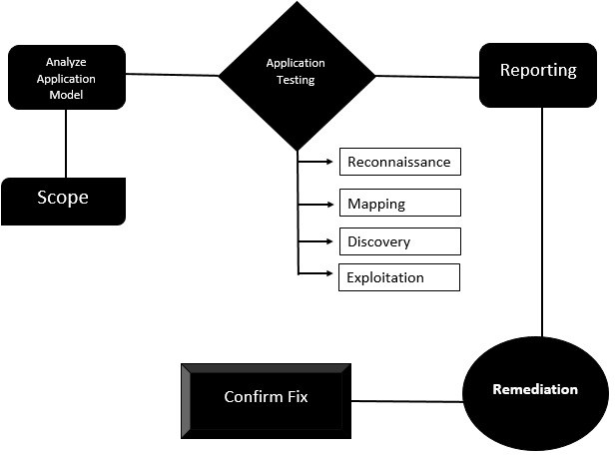

### Standards Followed: OWASP Top 10 & Own Manual Methods

### 

**OWASP**

The Open Web Application Security Project (OWASP) is a worldwide nonprofit charitable organization focused on improving the security of software. OWASP is involved in detecting and combating leaks in application security and techniques. They provide testers and developers guidelines to create secure applications.

The OWASP Top Ten is a list of vulnerabilities determined by identifying some of the most critical risks faced by web applications. The OWASP Top 10 is referenced by many standards, books, tools, and organizations such as MITRE, PCI DSS, DISA, FTC, and others.

* Broken Access Control
* Cryptographic Failures
* Injection
* Insecure Design
* Security Misconfiguration
* Vulnerable and Outdated Components
* Identification and Authentication Failures
* Software and Data Integrity Failures
* Security Logging and Monitoring Failures
* Server-Side Request Forgery (SSRF)

In security analysis, priority is given to the user and user data, which is targeted the most. Vulnerabilities that pose a threat to user data are a security concern.

# **Severity Description**



|  |  |  |
| --- | --- | --- |
| **Severity** | **Score** | **Description** |
| **Critical** | **10** | All vulnerabilities mentioned above should be patched as soon as possible before the re-audit, as there are suitable patches provided with every vulnerability. |
| **High** | **7-9** | Vulnerabilities with a high or greater business impact and high or greater likelihood are considered High severity. |
| **Medium** | **4-6** | Vulnerabilities with a medium business impact and likelihood are considered medium severity. This also includes vulnerabilities that have either very high business impact combined with a low likelihood or have a low business impact combined with a very high likelihood. |
| **Low** | **1-3** | Vulnerabilities that have either a very low business impact, maximum high likelihood, or very low likelihood, maximum high business impact, are considered Low severity. Also, vulnerabilities where both business impact and likelihood are low are considered Low severity. |
| **Informational** | **0.0** | Vulnerabilities that provide specific bits of information to the end-user that were not designed to be released, yet have no specific security impact on the application, host, or environment. |

# **Scope of work & VAPT Findings**



|  |  |  |  |
| --- | --- | --- | --- |
| **Sr. No.** | **Type of Asset** | **Host Name** | **IP Address** |
| 1 | Website | <https://testfire.net> | **-** |
| 2 | Website | <https://www.mlsa.gov.mv> | **172.67.174.237** |

|  |
| --- |
|  |

**Vulnerability Table**



|  |  |  |  |  |
| --- | --- | --- | --- | --- |
| **Sr. No** | **Vulnerability Discovered** | **Vulnerable URL** | **Severity** | **Status** |
| 1 | HTML Injection | https://testfire.net | **Medium** | **Open** |
| 2 | File Path Manipulation | https://testfire.net | **Low** | **Open** |
| 3 | Cross Site Scripting (XSS) | https://testfire.net | **High** | **Open** |
| 4 | SQL Injection to Bypass Authentication | https://testfire.net | **Critical** | **Open** |
| 5 | Insecure Direct Object Reference | https://testfire.net | **Critical** | **Open** |
| 6 | Security Logging and Monitoring | https://testfire.net | **Medium** | **Open** |
| 7 | Cross Site Scripting (XSS) | https://mlsa.gov.mv | **High** | **Open** |

**Vulnerability Summary**



|  |  |  |  |  |
| --- | --- | --- | --- | --- |
| 2 | 2 | 2 | 1 | 0 |
| Critical | High | Medium | Low | Informational |

**Enumeration of Website**



**URL/IP:** http://testfire.net

**Scan Performed:** Whois

**Findings:** whois scan was performed to get domain & registrant information.

**Proof of Concept:**

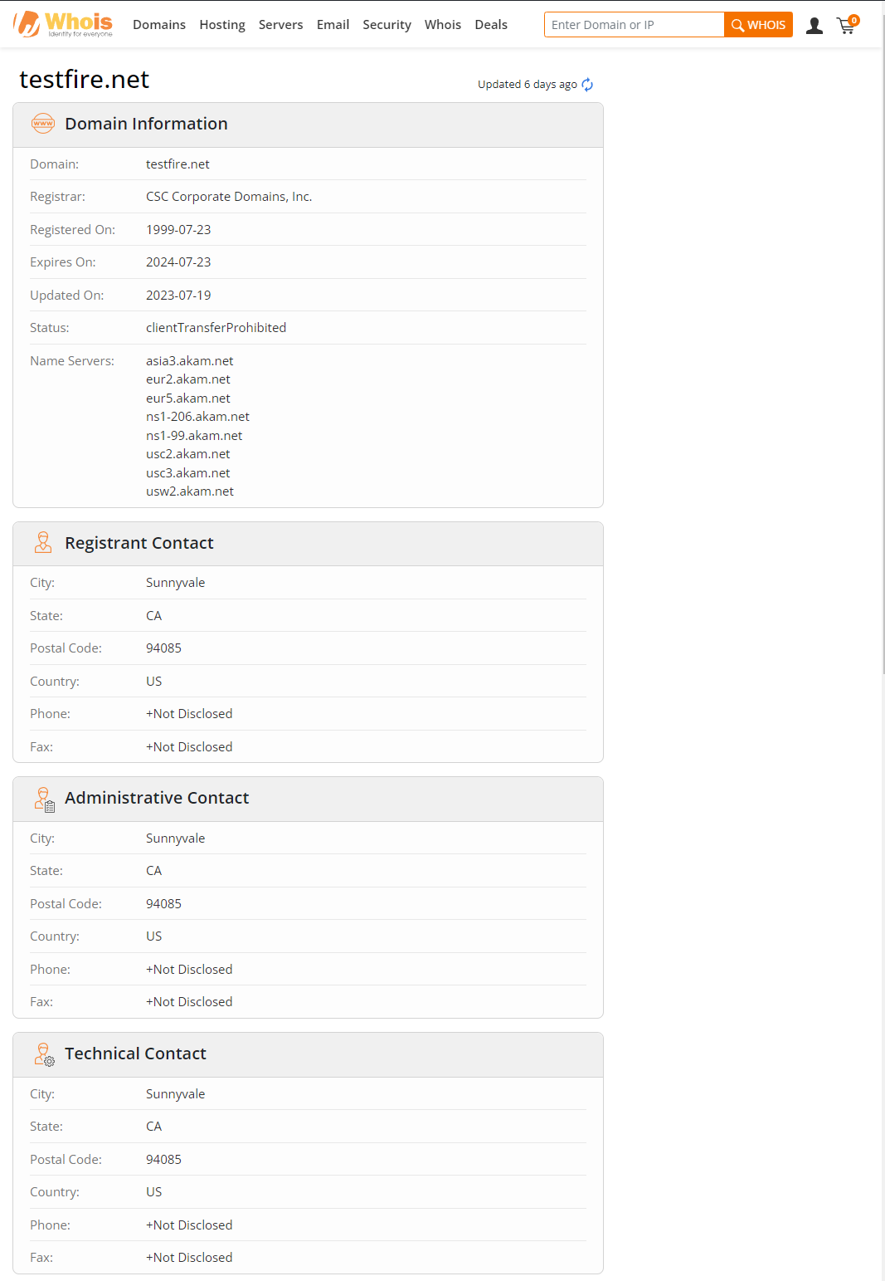



**URL/IP:** http://testfire.net

**Scan Performed:** Subdomain Scan with Subfinder

**Findings:** found 8 Subdomain With subfinder tool

**Proof of Concept:**

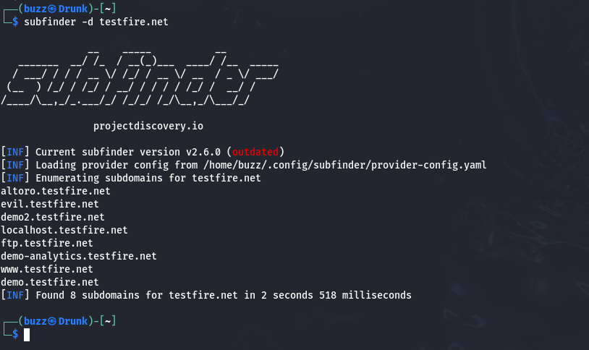



**URL/IP:** http://testfire.net

**Scan Performed:** Subdomain of subdomain with subfinder

**Findings:** Didn’t get any subdomain of subdomain ☹

**Proof of Concept:**

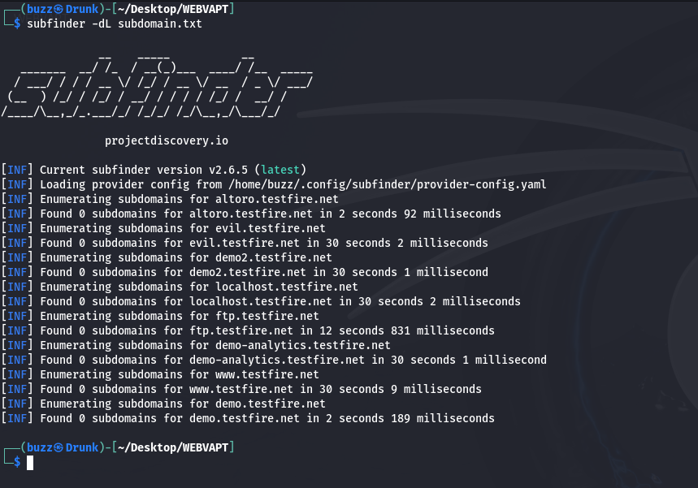



**URL/IP:** http://testfire.net

**Scan Performed:** What Web Scan

**Findings:** We have performed What web scan on target to detect Backend Technologies.

**Proof of Concept:**

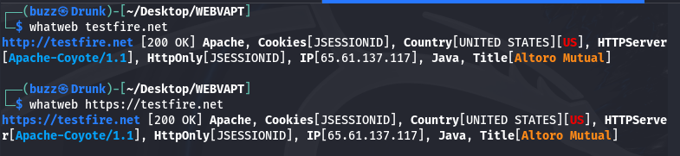

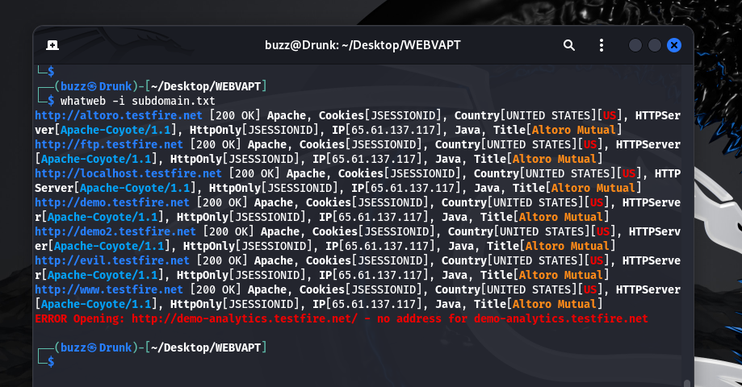



**URL/IP:** http://testfire.net

**Scan Performed:** Wappalyzer

**Findings:** We have performed Wappalyzer scan on target to detect Backend Technologies.

**Proof of Concept:**

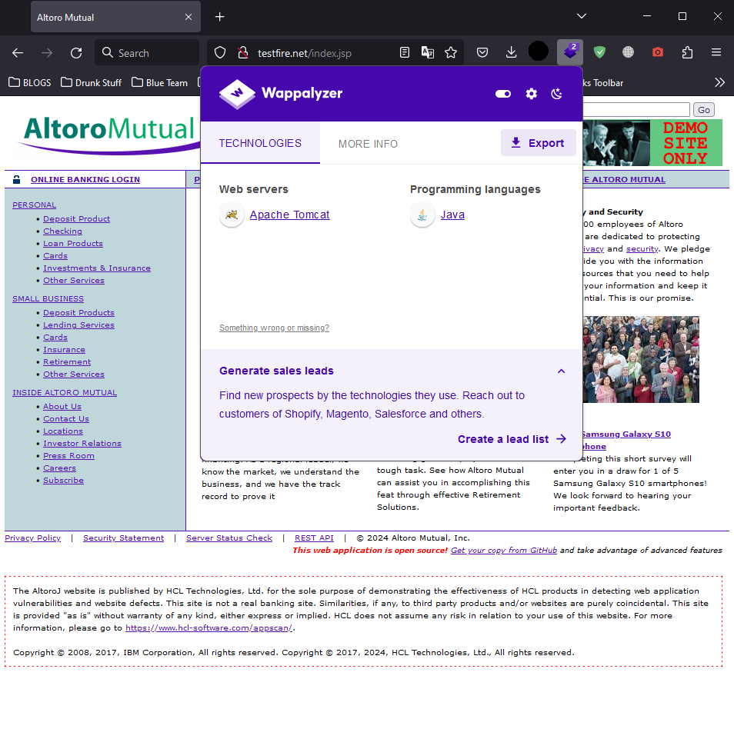



**URL/IP:** http://testfire.net

**Scan Performed:** Dnsrecon

**Findings:** Enumerate General DNS Records for a given Domain (MX, SOA, NS, A, AAAA, SPF and TXT).

**Proof of Concept:**

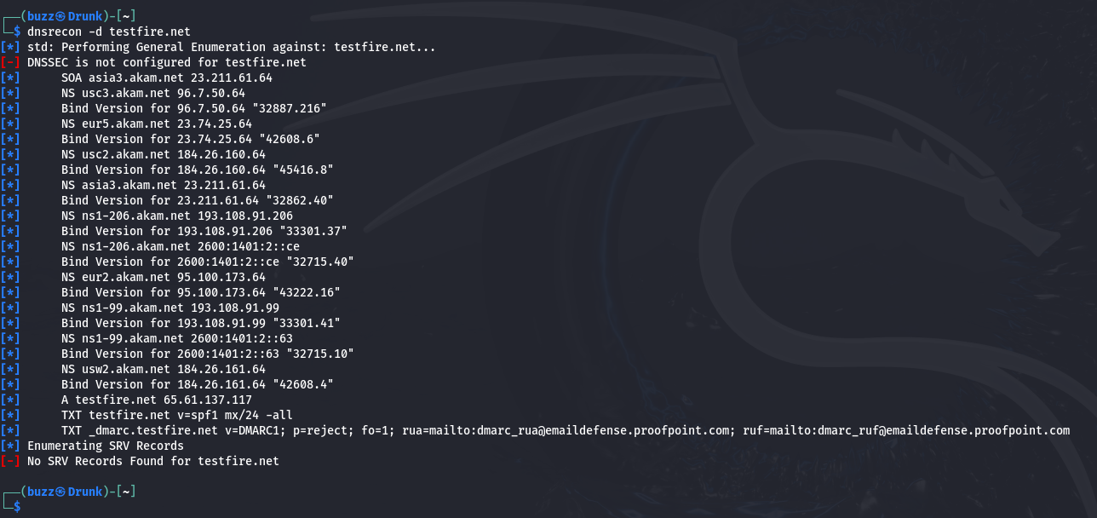



**URL/IP:** http://testfire.net

**Scan Performed:** amass

**Findings:** amass will give DNS recodes and IP ranges

**Proof of Concept:**

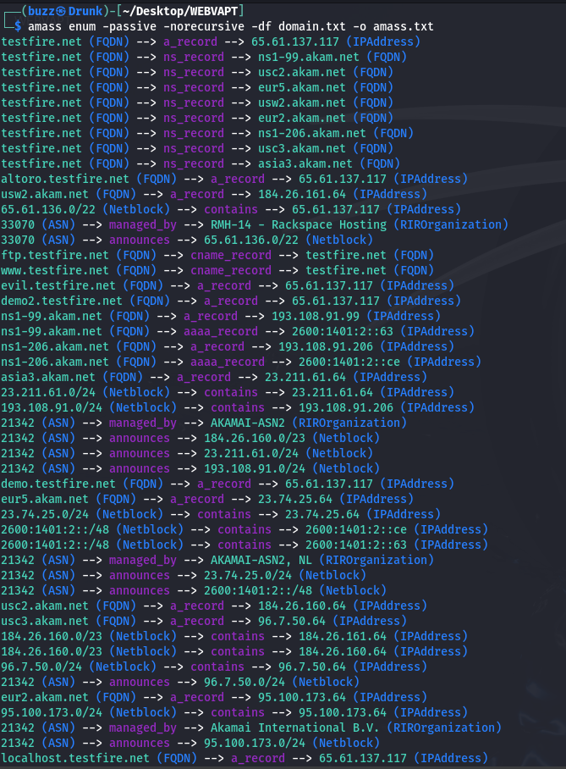



**URL/IP:** http://testfire.net

**Scan Performed:** Nmap

**Findings:** Nmap Give information about Open Port And their server version also we got operating system and traceroute.

**Proof of Concept:**

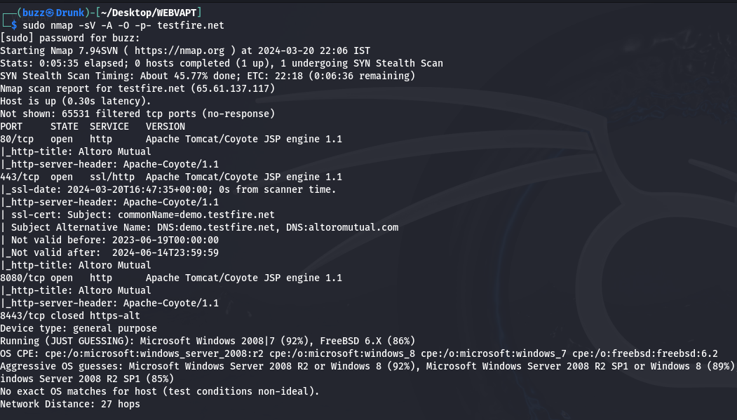

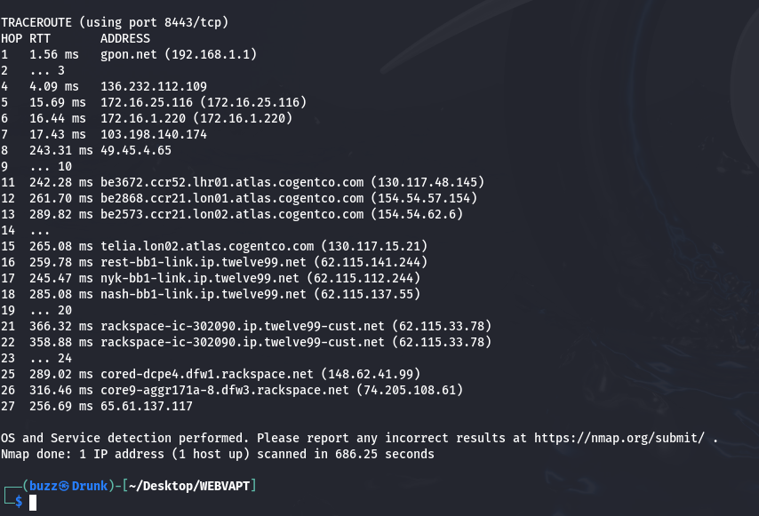

**URL/IP:** http://testfire.net

**Scan Performed:** ffuf

**Findings:** ffuf will give information about some open directory with some status code like 200,301,302,403.

**Proof of Concept:**

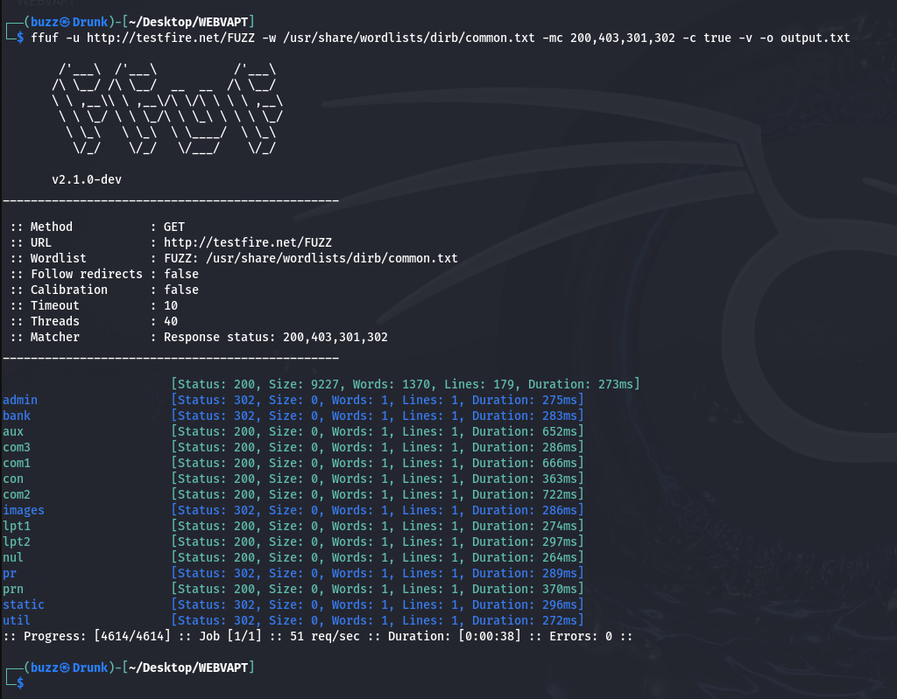



**URL/IP:** http://testfire.net

**Scan Performed:** IP History

**Findings:** Shows a historical list of IP addresses a given domain name has been hosted on as well as where that IP address is geographically located, and the owner of that IP address.

**Proof of Concept:**

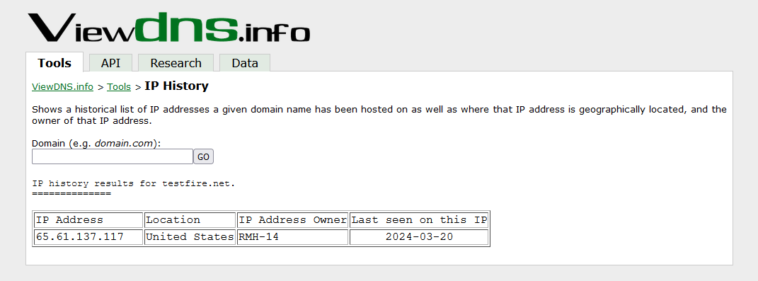



**URL/IP:** http://testfire.net

**Scan Performed:** Reverse IP domain Check

**Findings:** Find other sites hosted on a web server by entering a domain or IP address above.

**Proof of Concept:**

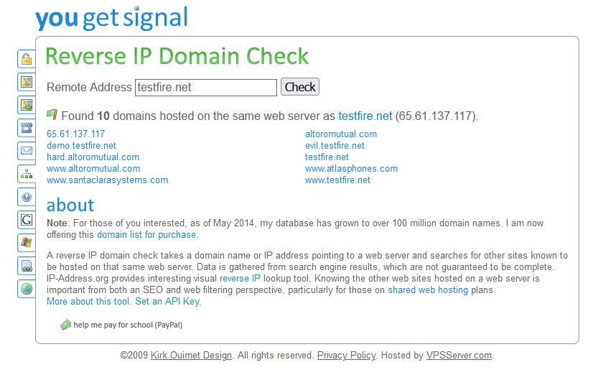



**URL/IP:** http://testfire.net

**Scan Performed:** sslscan

**Findings:**  SSL Scan give information of server key exchange groups and information of server signature algorithms

**Proof of Concept:**

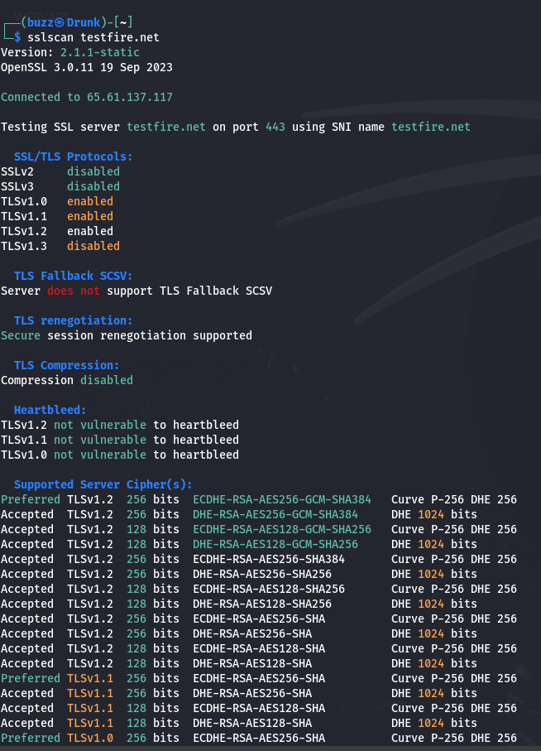

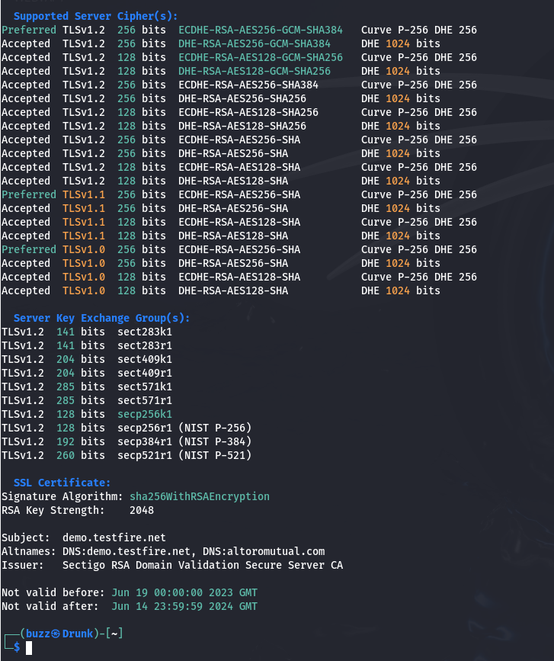



**URL/IP:** http://testfire.net

**Scan Performed:** Nessus Scan

**Findings:** We have also performed VA with the help of Nessus scanner but no such flaws where detected.

**Proof of Concept:**

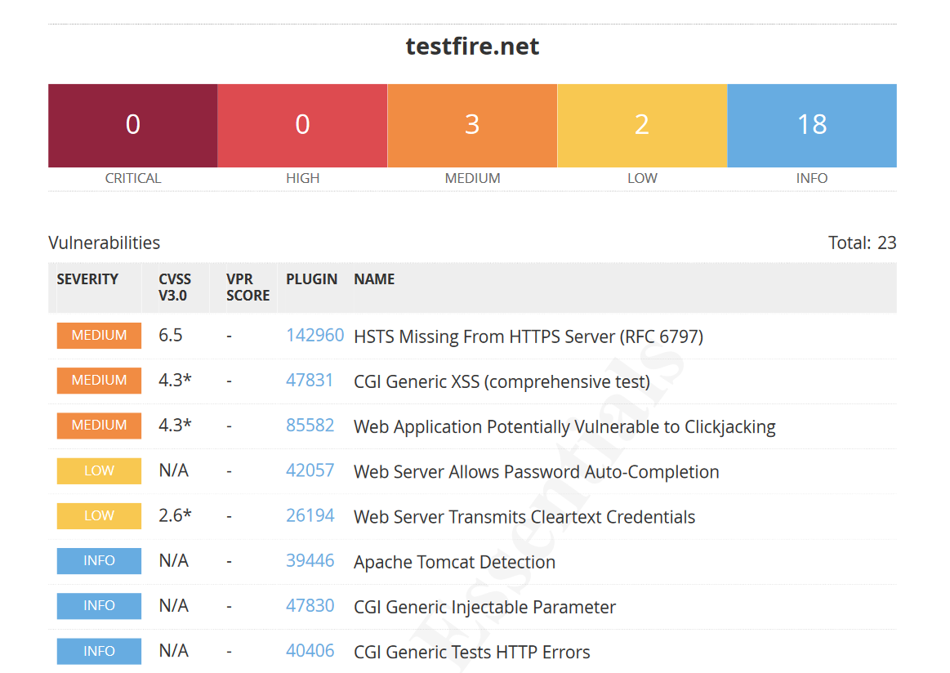

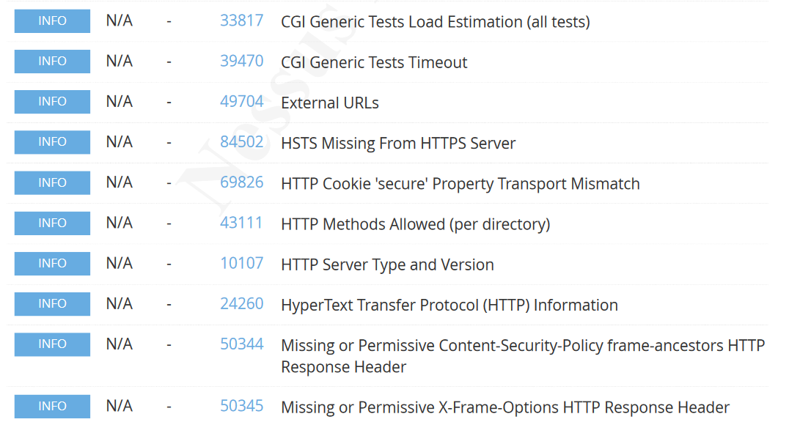



**URL/IP:** https://www.mlsa.gov.mv/

**Scan Performed:** Subdomain Scan with Subfinder

**Findings:** found 4 Subdomain With subfinder tool

**Proof of Concept:**

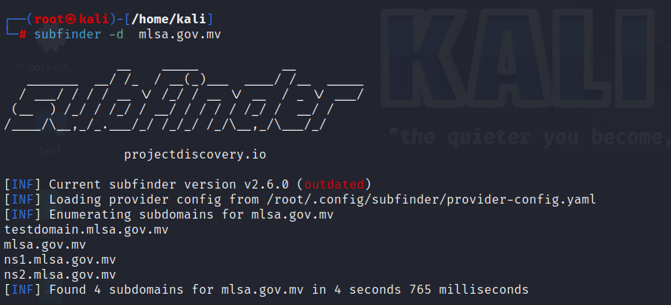



**URL/IP:** https://www.mlsa.gov.mv/

**Scan Performed:** Subdomain of subdomain with subfinder

**Findings:** Didn’t get any subdomain of subdomain ☹

**Proof of Concept:**

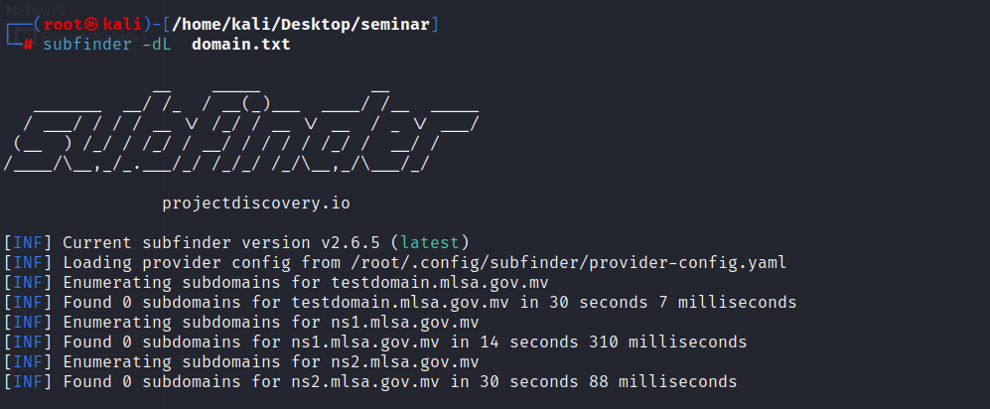



**URL/IP:** https://www.mlsa.gov.mv

**Scan Performed:** Wappalyzer

**Findings:** We have performed Wappalyzer scan on target to detect Backend Technologies.

**Proof of Concept:**





**URL/IP:** https://www.mlsa.gov.mv

**Scan Performed:** Dnsrecon

**Findings:** Enumerate General DNS Records for a given Domain (MX, SOA, NS, A, AAAA, SPF and TXT).

**Proof of Concept:**

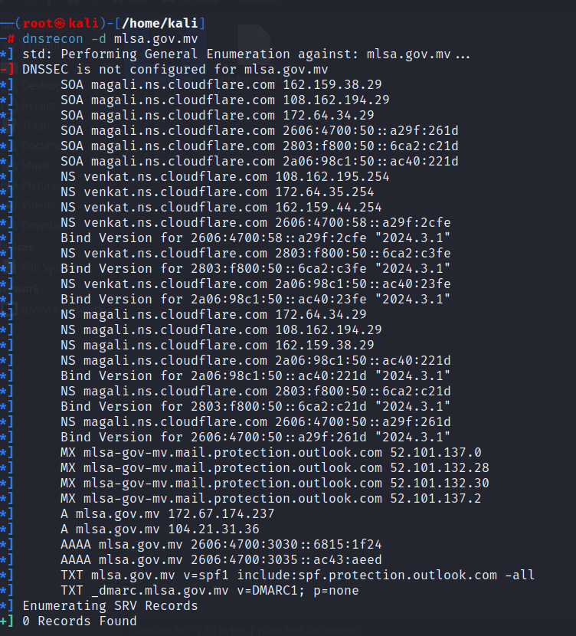



**URL/IP:** https://www.mlsa.gov.mv

**Scan Performed:** Nmap

**Findings:** Nmap Give information about Open Port And their server version also we got operating system and traceroute.

**Proof of Concept:**

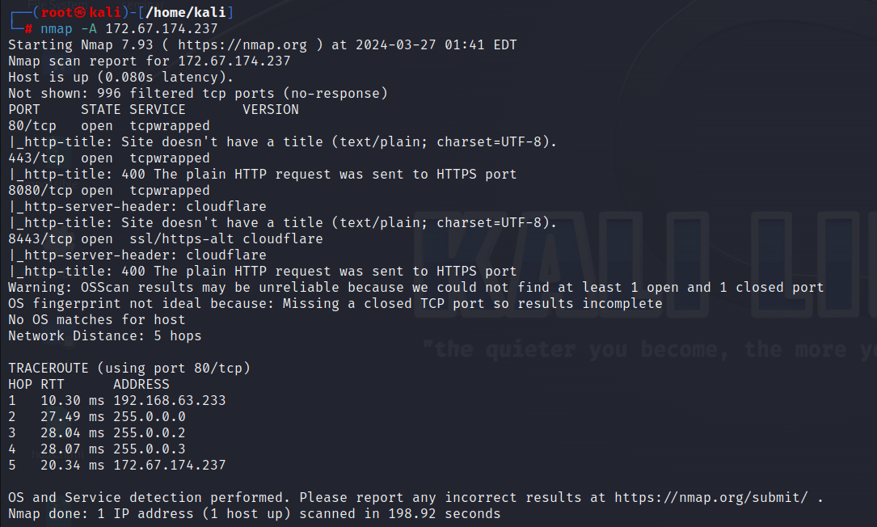

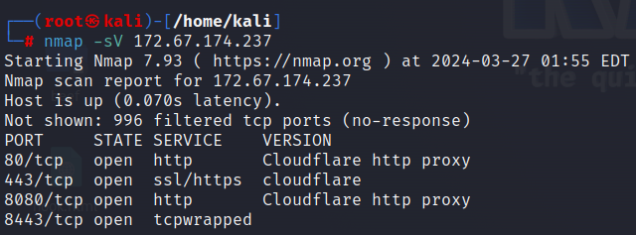



**URL/IP:** https://www.mlsa.gov.mv

**Scan Performed:** Shodan

**Findings:** states the open ports information and domain registration details via Shodan search engine.

**Proof of Concept:**

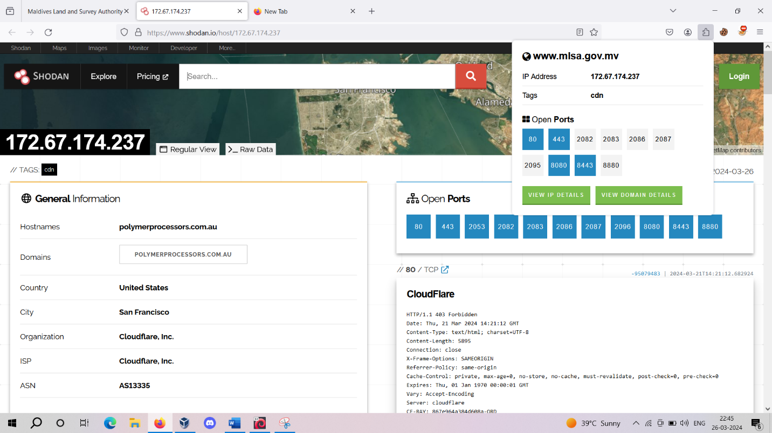

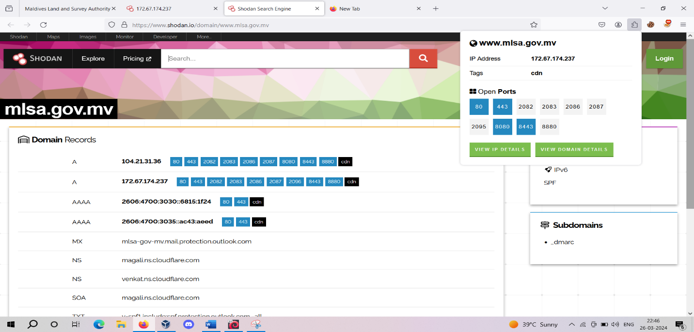



**URL/IP:** https://www.mlsa.gov.mv

**Scan Performed:** Traceroute

**Findings:** A traceroute provides a map of how data on the internet travels from its source to its destination. When you connect with a website, the data you get must travel across multiple devices and networks along the way, particularly routers.

**Proof of Concept:**

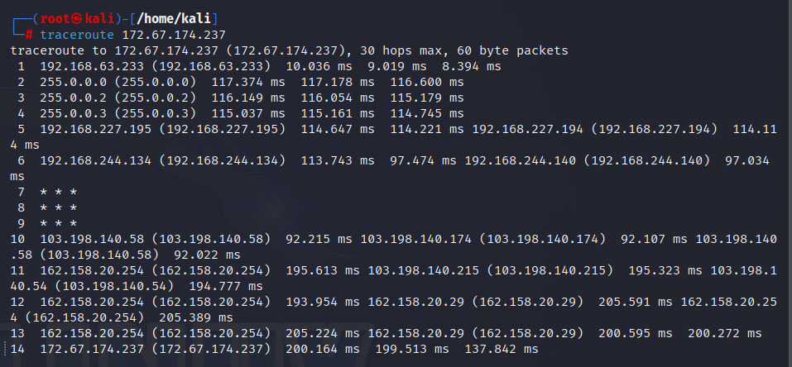



**URL/IP:** https://www.mlsa.gov.mv

**Scan Performed:** ffuf

**Findings:** ffuf will give information about some open directory with some status code like 200,301,302,403.

**Proof of Concept:**

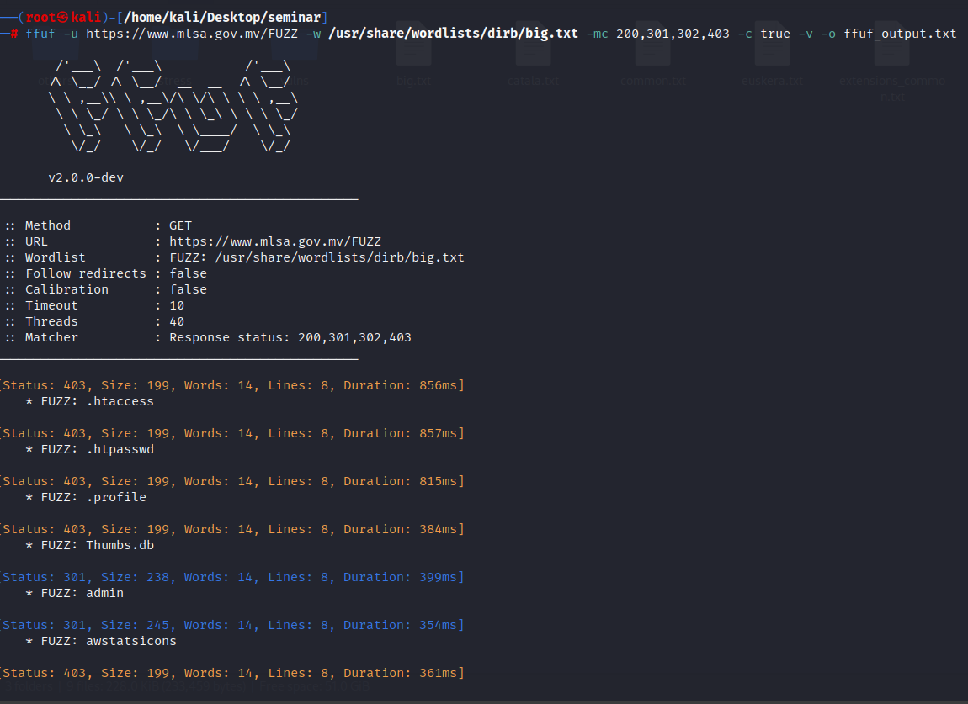



**URL/IP:** https://www.mlsa.gov.mv

**Scan Performed:** reverse IP lookup

**Findings:** Shows a reverse IP lookup of a given domain name has been hosted on as well as where that IP address is geographically located, and the owner of that IP address.

**Proof of Concept:**

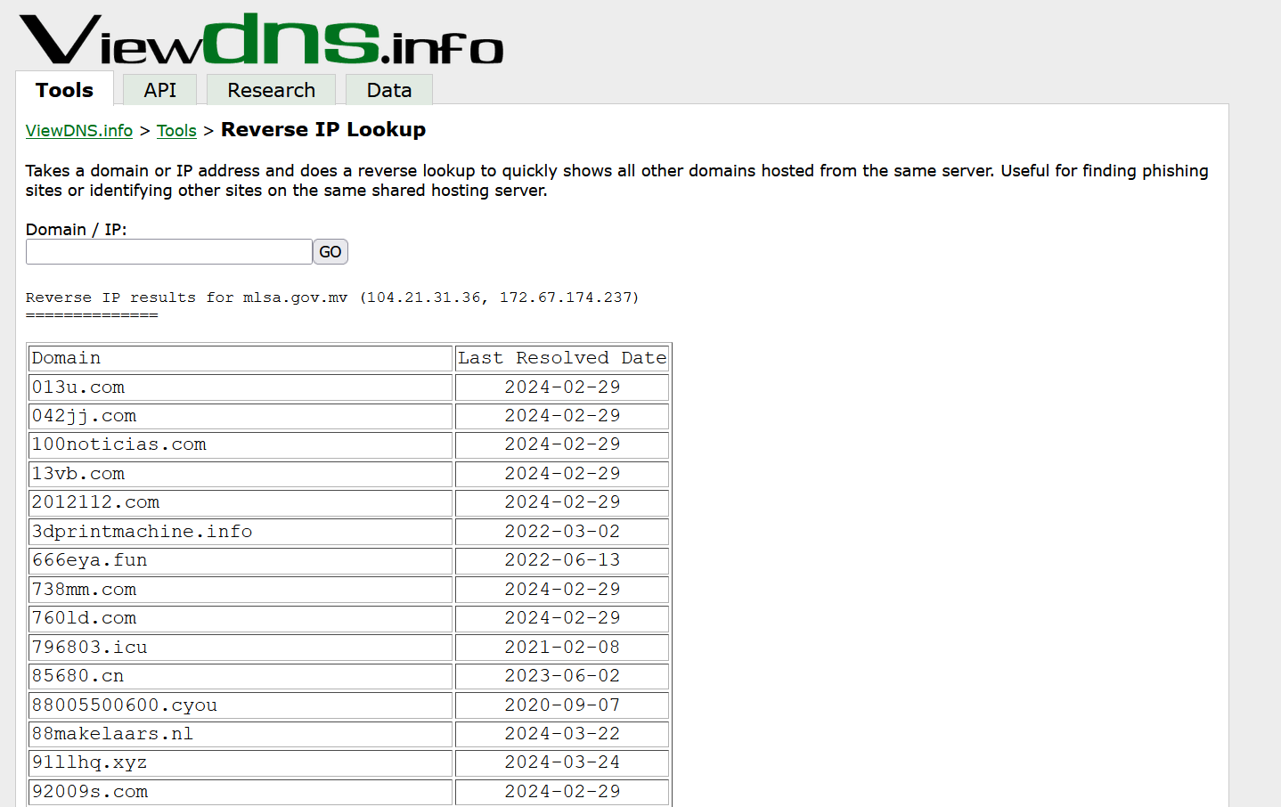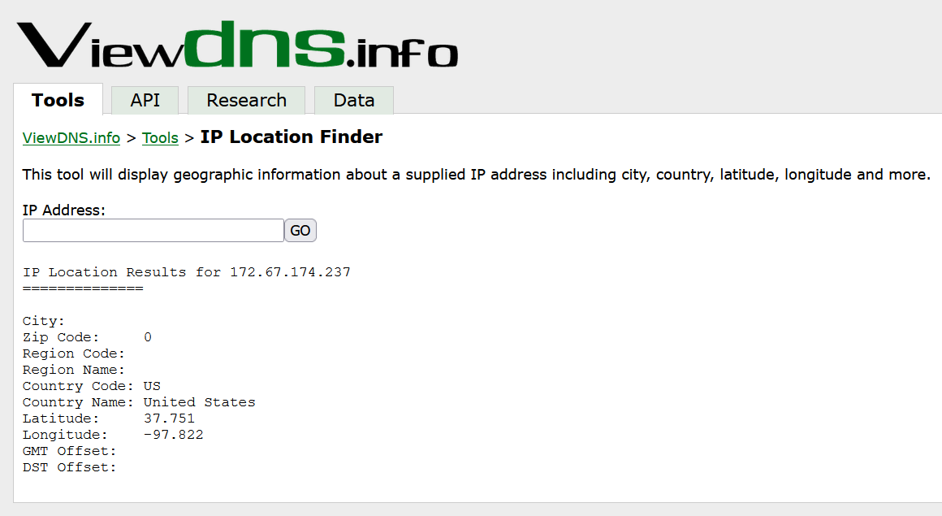



**URL/IP:** https://www.mlsa.gov.mv

**Scan Performed:** sslscan

**Findings:**  SSL Scan give information of server key exchange groups and information of server signature algorithms

**Proof of Concept:**

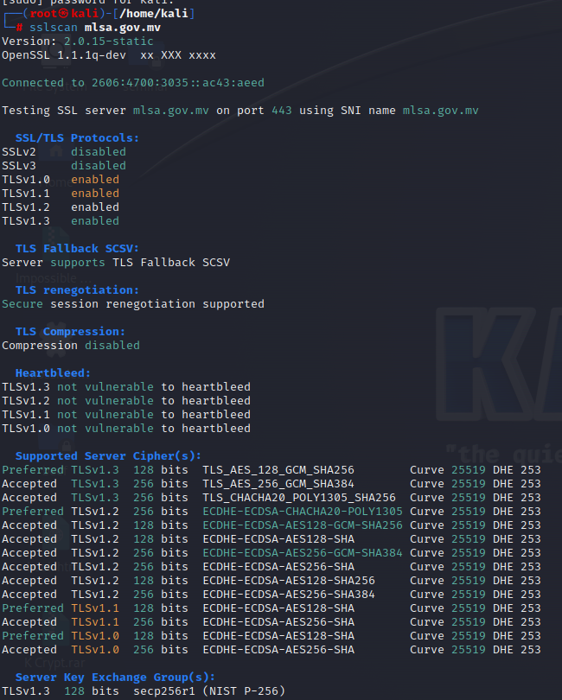

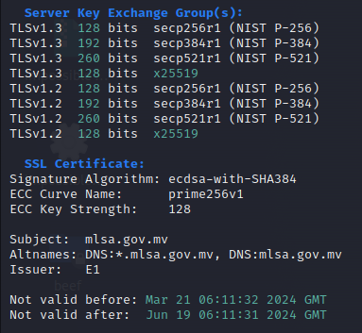



**URL/IP:** https://www.mlsa.gov.mv

**Scan Performed:** dirsearch

**Findings:** dirsearch will give information about some open directory

**Proof of Concept:**

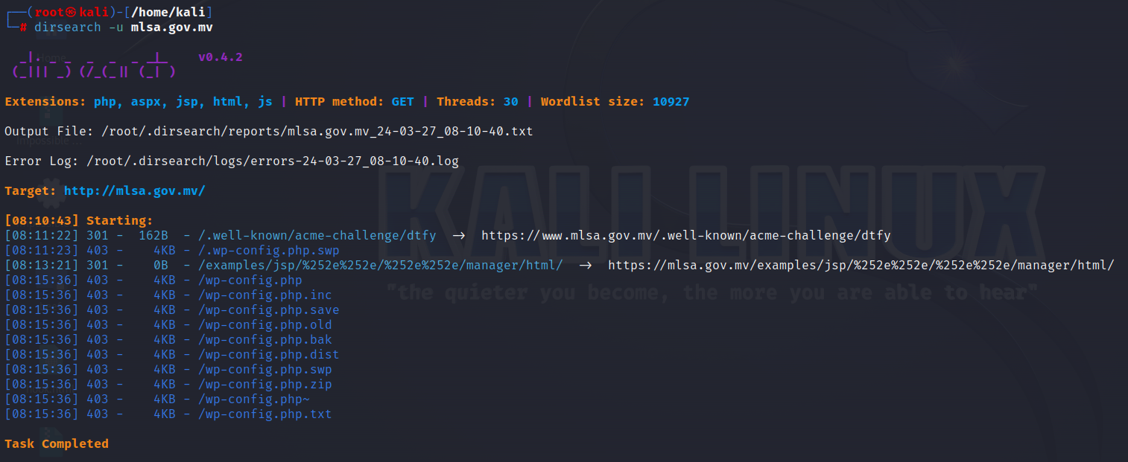



**URL/IP:** https://www.mlsa.gov.mv/

**Scan Performed:** Nessus Scan

**Findings:** We have also performed VA with the help of Nessus scanner but no such flaws where detected.

**Proof of Concept:**

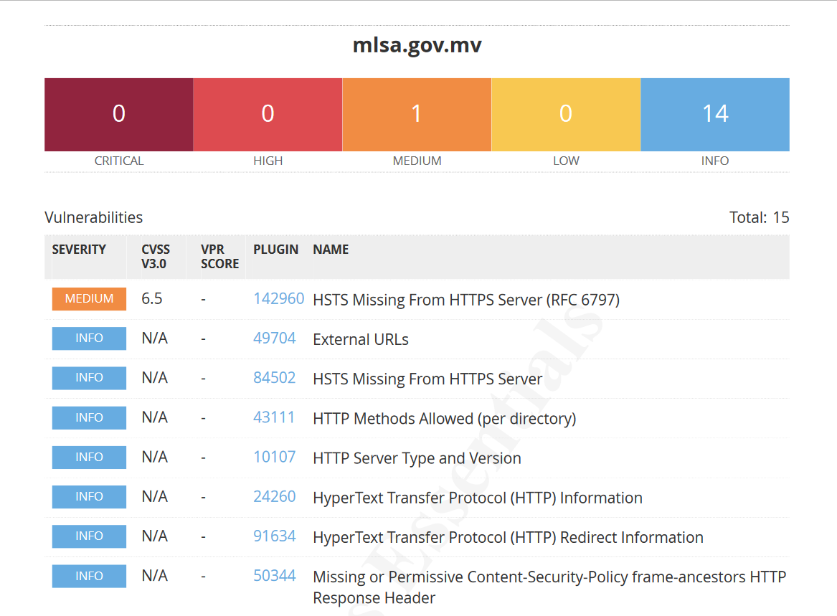

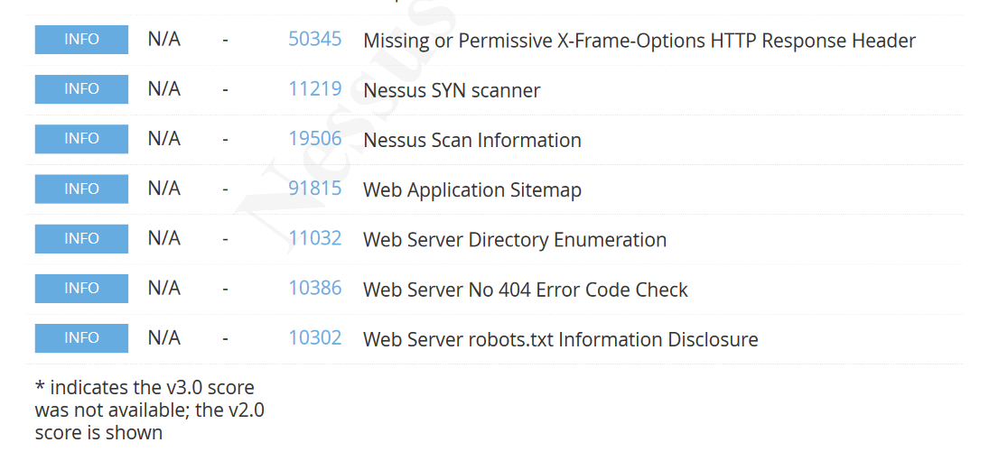

**Technical Narration of Website Vulnerability**

1. **Vulnerability Name:**

HTML Injection

* **Vulnerable URL**

<http://testfire.net/search.jsp?query=%3Ch1%3E%3Cmarquee%3EHey+Khushboo%3C%2Fh1%3E%3C%2Fmarquee%3E>

* **Severity**

**Medium**

* **Description**

HTML Injection also known as Cross Site Scripting. It is a security vulnerability that allows an attacker to inject HTML code into web pages that are viewed by other users.

* **Proof of concept**

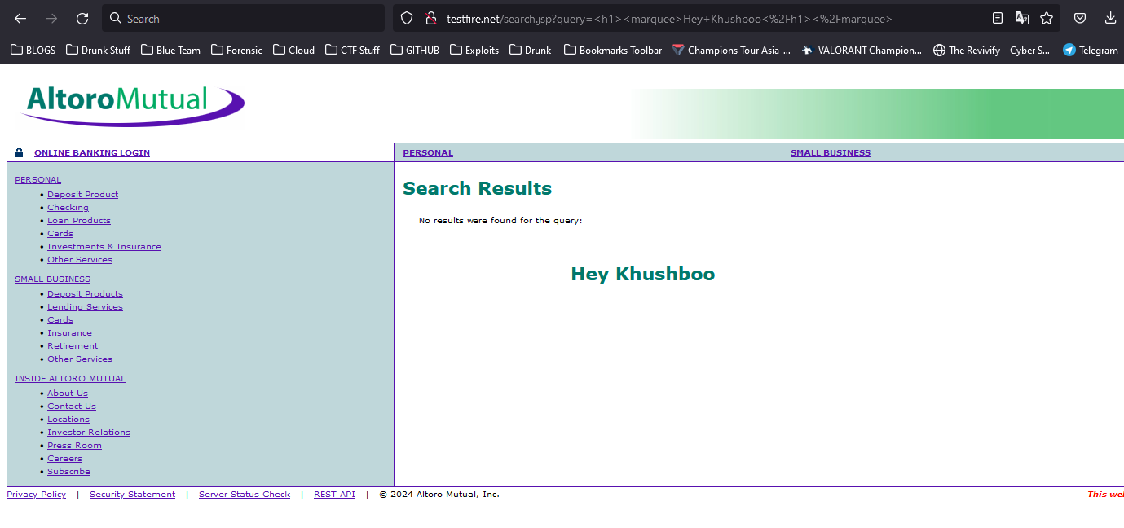

* **Impact**
* A potential attacker could use it to modify the web page
* Using the HTML Injection vulnerability, threat actors can produce bogus web pages.
* It can be used to steal a user’s identity.
* **Remediation**
* The developers can verify the user input by evaluating its length, type, and format.
* The programmer needs to configure his HTML script such that it removes metacharacters from user inputs.
* To prevent this attack the developer must validate the appropriate data.



1. **Vulnerability Name**

File path manipulation

* **Vulnerable URL**

<https://testfire.net/index.jsp?content=..%2fWEB-INF%2fweb.xml>

* **Severity**

**Low**

* **Description**

The **content** parameter appears to be vulnerable to file path manipulation attacks.  
  
The payload **../WEB-INF/web.xml** was submitted in the content parameter. The file WEB-INF/web.xml was returned.

* **Proof of concept**

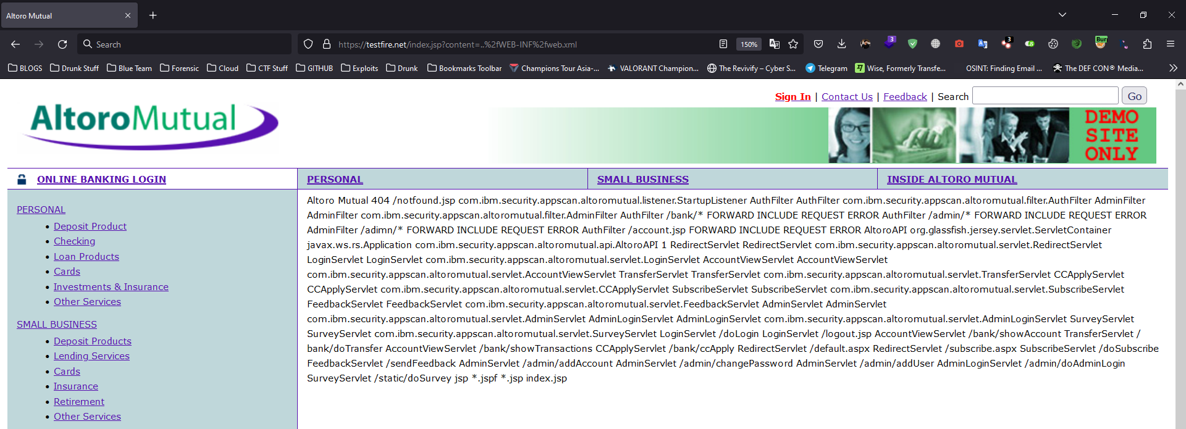

* **Impact**

File path manipulation vulnerabilities arise when user-controllable data is placed into a file or URL path that is used on the server to access local resources, which may be within or outside the web root. If vulnerable, an attacker can modify the file path to access different resources, which may contain sensitive information. Even where an attack is constrained within the web root, it is often possible to retrieve items that are normally protected from direct access, such as application configuration files, the source code for server-executable scripts, or files with extensions that the web server is not configured to serve directly.

* **Remediation**
* Ideally, application functionality should be designed in such a way that user-controllable data does not need to be placed into file or URL paths in order to access local resources on the server. This can normally be achieved by referencing known files via an index number rather than their name.
* If it is considered unavoidable to place user data into file or URL paths, the data should be strictly validated against a whitelist of accepted values. Note that when accessing resources within the web root, simply blocking input containing file path traversal sequences (such as dot-dot-slash) is not always sufficient to prevent retrieval of sensitive information, because some protected items may be accessible at the original path without using any traversal sequences.



1. **Vulnerability Name**

Cross-site scripting (reflected)

* **Vulnerable URL**

<http://testfire.net/search.jsp?query=%3cscript%3ealert(%22xss%22)%3c%2fscript%3e>

* **Severity**

**High**

* **Description**

Reflected cross-site scripting vulnerabilities arise when data is copied from a request and echoed into the application's immediate response in an unsafe way. An attacker can use the vulnerability to construct a request that, if issued by another application user, will cause JavaScript code supplied by the attacker to execute within the user's browser in the context of that user's session with the application.

The attacker-supplied code can perform a wide variety of actions, such as stealing the victim's session token or login credentials, performing arbitrary actions on the victim's behalf, and logging their keystrokes.

* **Proof of concept**

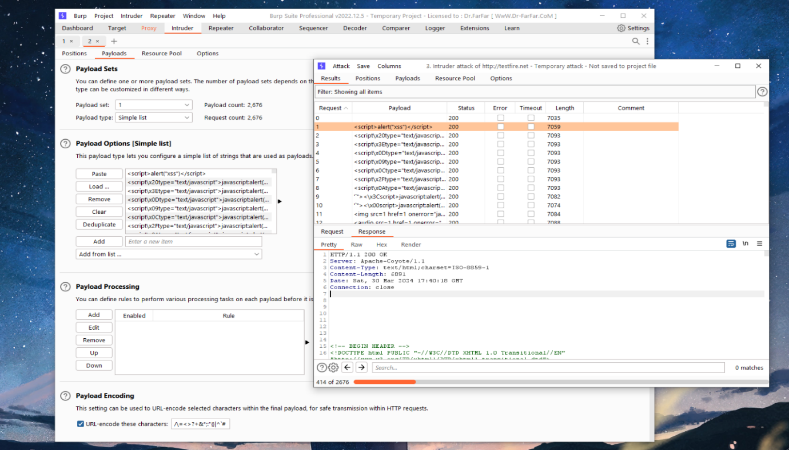

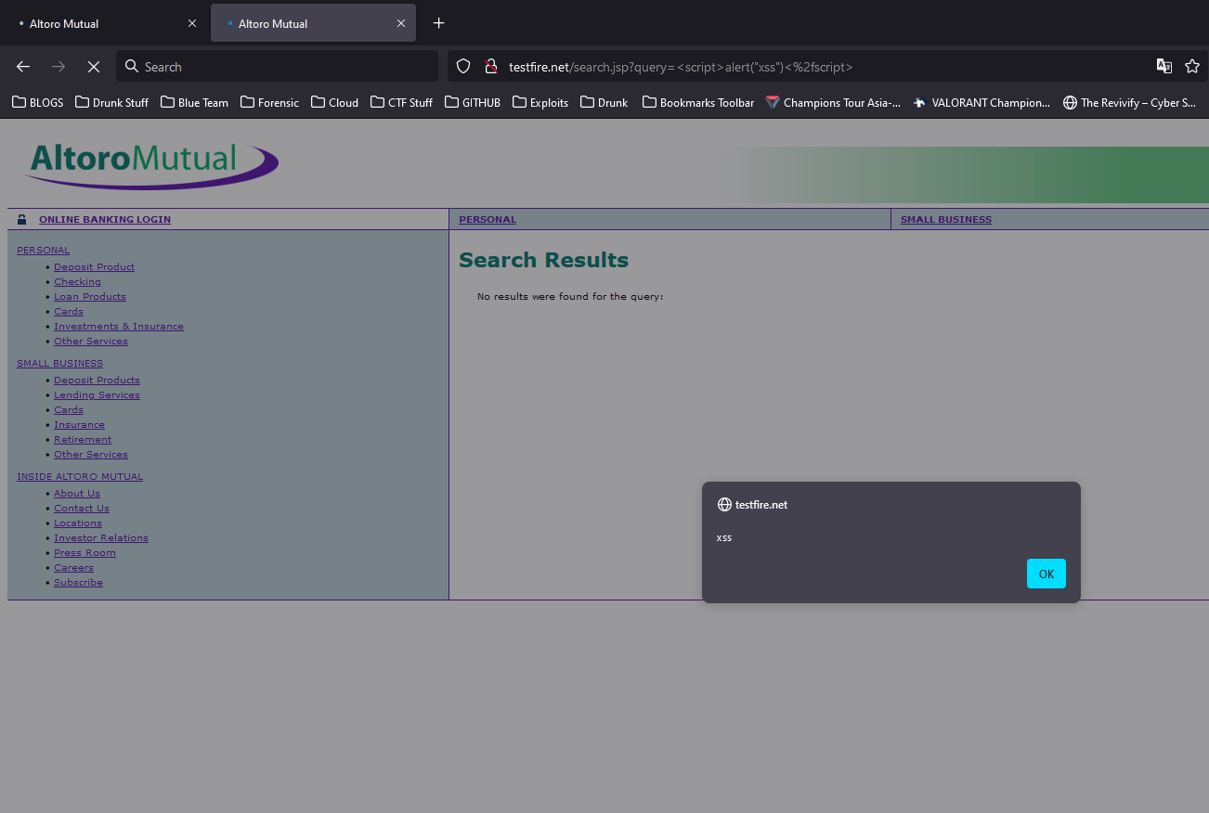

* **Impact**

If an attacker can control a script that is executed in the victim's browser, then they can typically fully compromise that user. Amongst other things, the attacker can

* Perform any action within the application that the user can perform.
* View any information that the user is able to view.
* Modify any information that the user is able to modify.
* Initiate interactions with other application users, including malicious attacks, that will appear to originate from the initial victim user.
* **Remediation**

In most situations where user-controllable data is copied into application responses, cross-site scripting attacks can be prevented using two layers of defenses

* Input should be validated as strictly as possible on arrival, given the kind of content that it is expected to contain. For example, personal names should consist of alphabetical and a small range of typographical characters, and be relatively short; a year of birth should consist of exactly four numerals; email addresses should match a well-defined regular expression. Input which fails the validation should be rejected, not sanitized.
* User input should be HTML-encoded at any point where it is copied into application responses. All HTML metacharacters, including < > " ' and =, should be replaced with the corresponding HTML entities (&lt; &gt; etc).



**4.Vulnerability Name**

SQL Injection to Bypass Authentication

* **Vulnerable URL**

<http://testfire.net/bank/main.jsp>

* **Severity**

**Critical**

* **Description**

SQL injection is a technique used to exploit user data through web page inputs by injecting SQL commands as statements. Basically, these statements can be used to manipulate the application’s web server by malicious users.

SQL injection is a code injection technique that might destroy your database.

SQL injection is one of the most common web hacking techniques.

SQL injection is the placement of malicious code in SQL statements, via web page input.

* **Proof of concept**

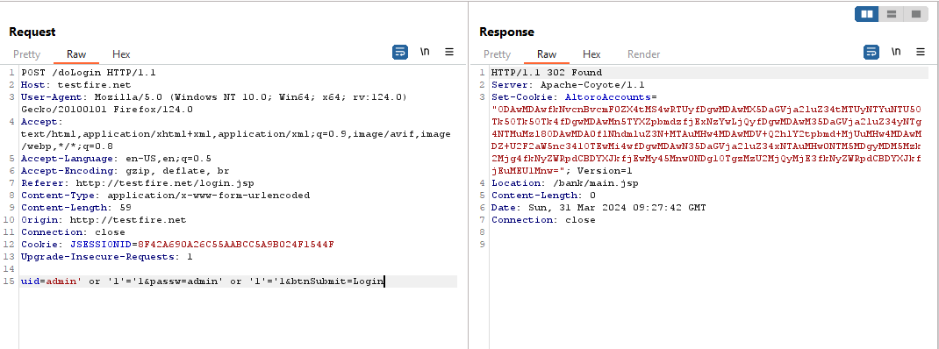

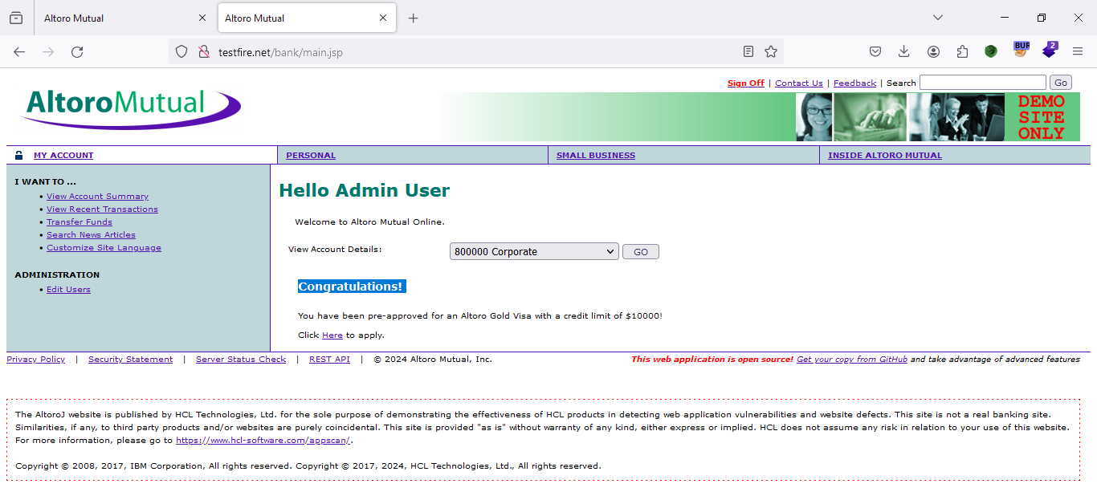

* **Impact**

Data Breach: sensitive data stored in the database, including personal information, financial records, or intellectual property.

Unauthorized Access: The attacker may exploit the vulnerability to gain unauthorized access

Data Manipulation: In addition to stealing data, attackers may also modify or delete data, leading to data corruption or loss.

* **Remediation**

Patch or Update: Apply any available patches or updates provided by the software vendor to fix the vulnerability.

Secure Authentication Mechanism: Implement strong authentication mechanisms, such as multi-factor authentication (MFA) or strong password policies, to prevent unauthorized access to the database.

Least Privilege Principle: Follow the principle of least privilege by granting users only the permissions they need to perform their tasks.



**5.Vulnerability Name**

Insecure Direct Object Reference

* **Vulnerable URL**

<http://testfire.net/bank/transfer.jsp>

* **Severity**

**Critical**

* **Description**

Insecure Direct Object Reference, a type of web application security vulnerability. IDOR occurs when an application uses user-supplied identifiers to access objects directly, such as database keys or file paths, without proper access controls. This can allow attackers to manipulate these identifiers and gain unauthorized access to sensitive data or perform unauthorized actions on the system.

* **Proof of concept**

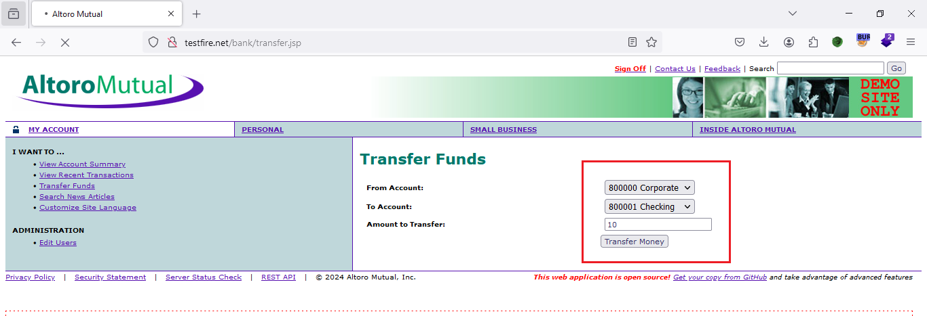

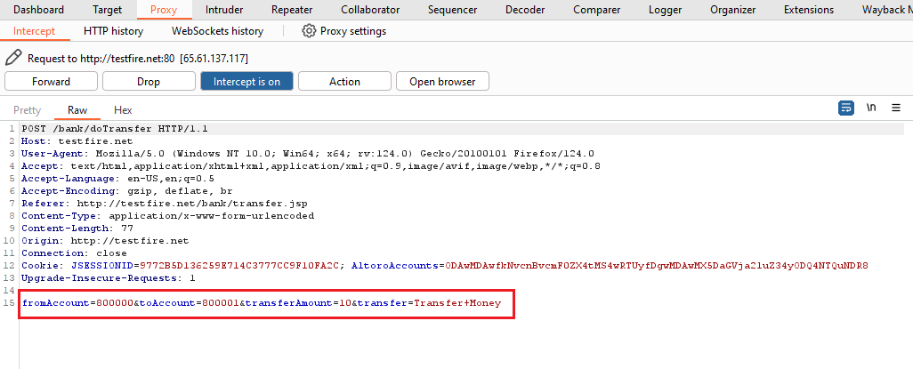

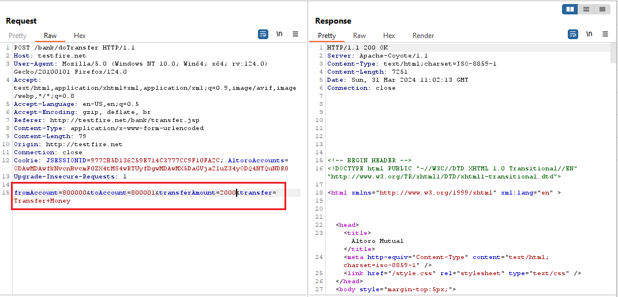

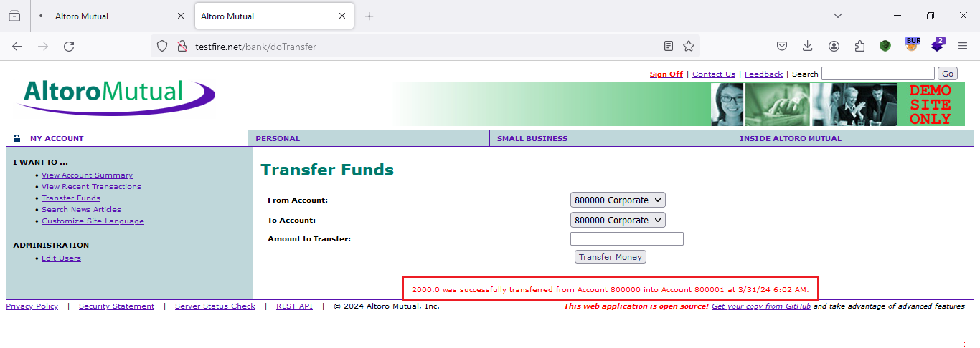

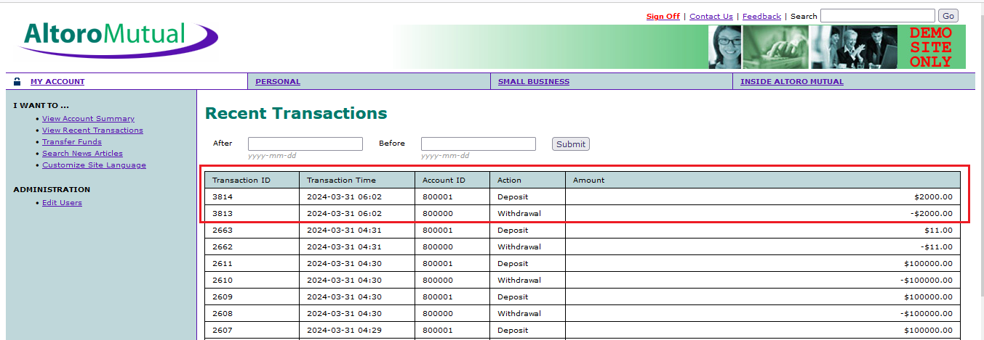

* **Impact**

Unauthorized Data Access: Attackers can exploit IDOR vulnerabilities to access sensitive data or resources that they are not authorized to view or manipulate.

Account Takeover: IDOR vulnerabilities may allow attackers to take over user accounts by accessing or modifying account-related resources, such as profile information or authentication tokens. This could result in identity theft or unauthorized actions performed on behalf of the victim.

Financial Losses: If attackers can manipulate sensitive resources related to financial transactions or accounts, they may be able to steal funds or conduct fraudulent activities, leading to financial losses for individuals or organizations.

* **Remediation**

Implement Proper Authorization Checks: Ensure that all sensitive resources and functionality are protected by appropriate authorization checks. Access should be granted only to authorized users or roles, and sensitive operations should require proper authentication.

Use Indirect References: Instead of exposing direct references to sensitive resources, use indirect references or identifiers that are not easily guessable or predictable. This can help prevent attackers from manipulating URLs or parameters to access unauthorized resources.

Apply Access Controls: Implement access controls at both the application and database levels to enforce the principle of least privilege. Regularly review and update access control policies to ensure that they reflect the current security requirements of the application.

Input Validation and Sanitization: Validate and sanitize all user inputs to prevent injection attacks and ensure that user-supplied data is safe to use. This includes inputs such as parameters, headers, and cookies that could be manipulated by attackers to exploit IDOR vulnerabilities.



**6.Vulnerability Name:**

Security logging and monitoring

* **Vulnerable URL**

<http://testfire.net/login.jsp>

* **Severity**

**Medium**

* **Description**

Security logging and monitoring failures are security vulnerabilities that can occur when a system or application fails to log or monitor security events properly. This can allow attackers to gain unauthorized access to systems and data without detection transmits or stores confidential information.

* **Proof of concept**

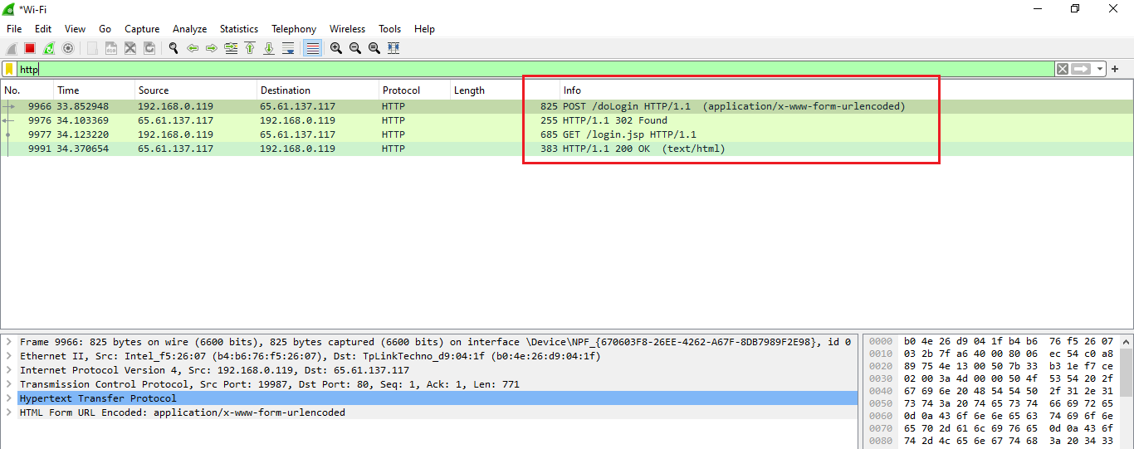

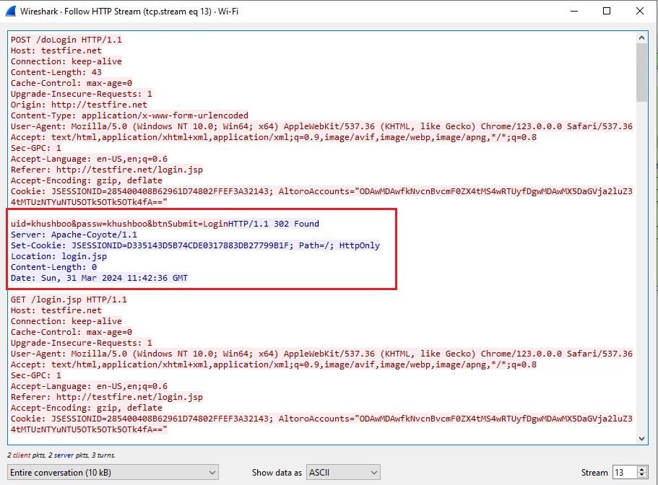

* **Impact**
* If vulnerable, an attacker can see the user credentials transmitted over the network and can be able to capture that.
* The connections have been exploited by ISPs and governments to track users, and to inject adverts and malicious JavaScript. Due to these concerns, web browser vendors are planning to visually flag unencrypted connections as hazardous.

* **Remediation**
* Applications should use transport-level encryption (SSL/TLS) to protect all communications passing between the client and the server. The Strict-Transport-Security HTTP header should be used to ensure that clients refuse to access the server over an insecure connection.
* Ensure all login, access control, and server-side input validation failures can be logged with sufficient user context to identify suspicious or malicious accounts and held for enough time to allow delayed forensic analysis.



**7. Vulnerability Name**

Cross-site scripting (reflected)

* **Vulnerable URL**

<https://www.mlsa.gov.mv/search.php?s=%3Cscript%20x%3E%20alert(%22khushboo%22)%20%3C%2fscript%201%3d2>

<https://www.mlsa.gov.mv/search.php?s=%3Cimg%20src=https://static.vecteezy.com/system/resources/previews/028/245/503/non_2x/india-flag-logo-vector-free-ai-generated-free-png.png%3E>

* **Severity**

**High**

* **Description**

Reflected cross-site scripting vulnerabilities arise when data is copied from a request and echoed into the application's immediate response in an unsafe way. An attacker can use the vulnerability to construct a request that, if issued by another application user, will cause JavaScript code supplied by the attacker to execute within the user's browser in the context of that user's session with the application.

The attacker-supplied code can perform a wide variety of actions, such as stealing the victim's session token or login credentials, performing arbitrary actions on the victim's behalf, and logging their keystrokes.

* **Proof of concept**

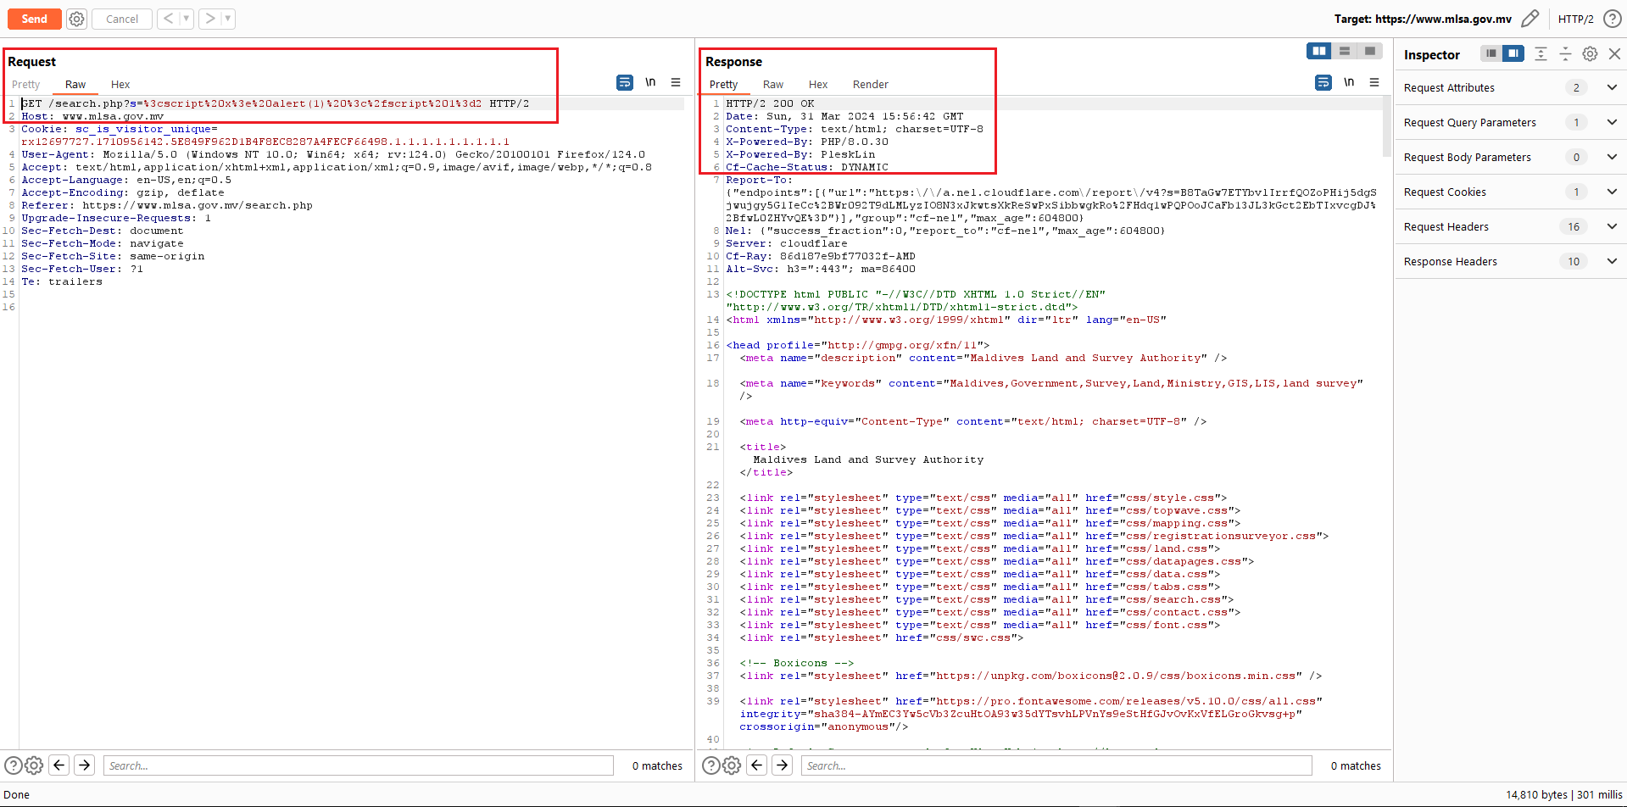

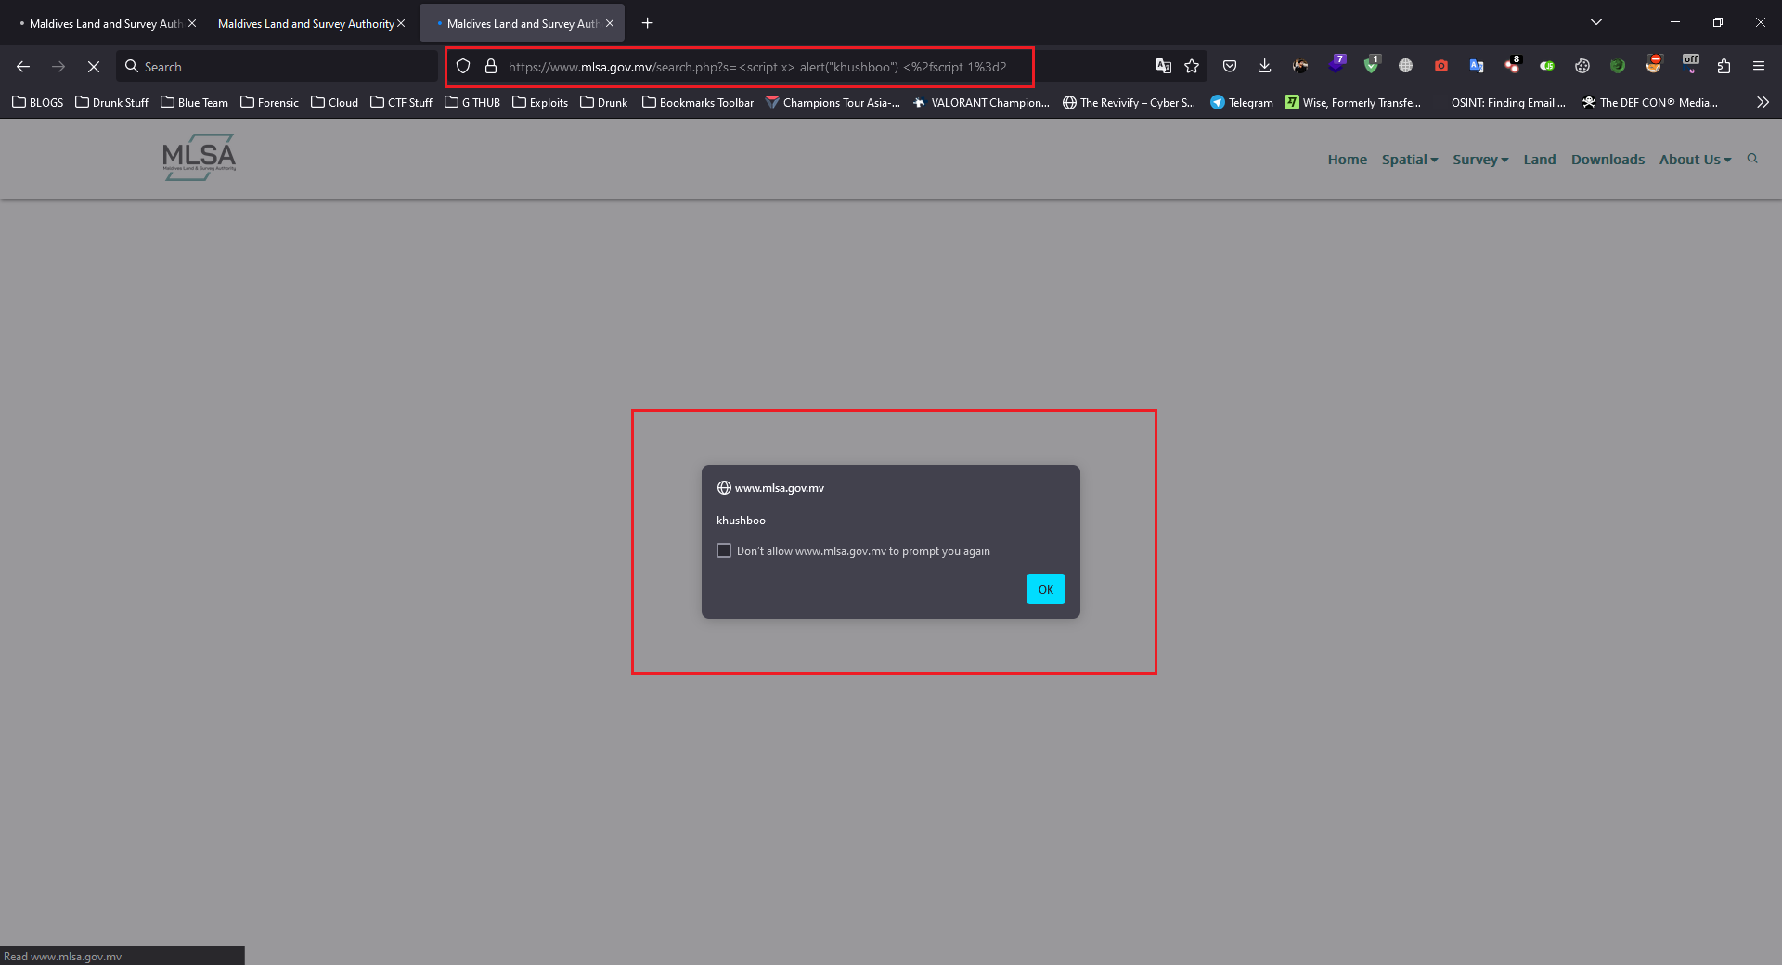

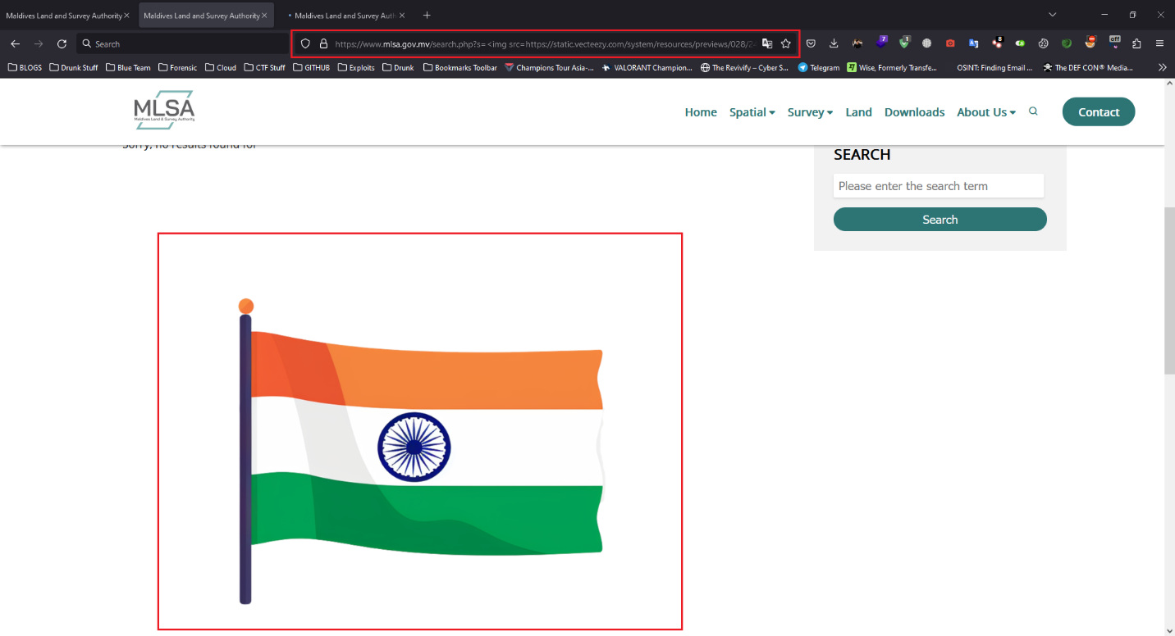

* **Impact**

If an attacker can control a script that is executed in the victim's browser, then they can typically fully compromise that user. Amongst other things, the attacker can

* Perform any action within the application that the user can perform.
* View any information that the user is able to view.
* Modify any information that the user is able to modify.
* Initiate interactions with other application users, including malicious attacks, that will appear to originate from the initial victim user.
* **Remediation**

In most situations where user-controllable data is copied into application responses, cross-site scripting attacks can be prevented using two layers of defenses

* Input should be validated as strictly as possible on arrival, given the kind of content that it is expected to contain. For example, personal names should consist of alphabetical and a small range of typographical characters, and be relatively short; a year of birth should consist of exactly four numerals; email addresses should match a well-defined regular expression. Input which fails the validation should be rejected, not sanitized.
* User input should be HTML-encoded at any point where it is copied into application responses. All HTML metacharacters, including < > " ' and =, should be replaced with the corresponding HTML entities (&lt; &gt; etc).



# **Conclusion**

The above-mentioned vulnerabilities were being tested and exploited by automated and manual methods for the verification of its severity by the approach of Blackbox and Greybox testing.

All vulnerabilities mentioned above should be patched as soon as possible; suitable patches are provided with every vulnerability.

**References**



* <https://owasp.org/www-project-top-ten/>
* <https://www.kali.org/>
* <https://adhilton.pratt.duke.edu/sites/adhilton.pratt.duke.edu/files/u37/ERSS_10_Tara_Guest_Lecture.pdf>
* <https://www.wireshark.org/docs/wsug_html/>
* <https://www.shodan.io/>
* <https://owasp.org/www-community/attacks/xss/>